COMMEMORATION OF WORLD DAY AGAINST CHILD LABOR 2026
Adansi Communities Unite Against Child Labour
New Edubiase, Ashanti Region, Ghana — June 2026
More than 500 people packed the grounds of New Edubiase Methodist School on 12 June to send a single message to their communities: child labour has no place in Adansi and Akrofuom. The gathering marked the World's Day Against Child Labour, and for the first time, three neighbouring districts — Adansi South, Adansi Asokwa, and Akrofuom — chose to hold the commemoration together, turning what is usually a local observance into a joint declaration of intent.
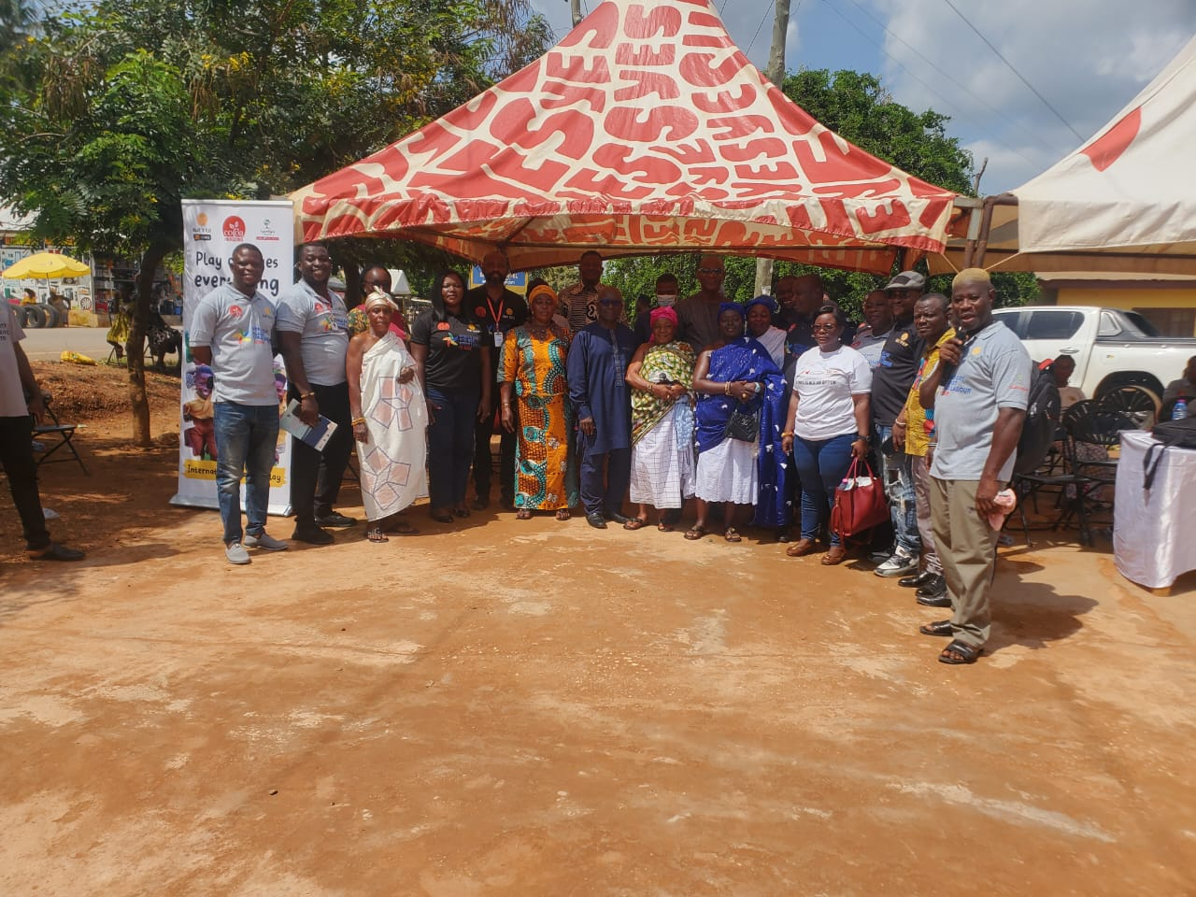
Delegation from Adansi Asokwa District with invited guests

A Theme Borrowed From the Pitch
This year's global theme, "Red Card to Child Labour: Fair Play for Children, Decent Work for Adults," leaned on the language of sport to make its point unmistakable. Just as a red card ends a player's involvement in a match for a serious foul, organisers argued, society must treat child labour as a serious violation that demands an immediate, decisive response — one that protects children's right to play, learn, and grow while ensuring adults have access to fair, dignified work.
Right to Play Ghana, the event's lead facilitating partner, brought that theme to life through community engagement, cultural performances, and youth-led activities that ran throughout the day.

Why It Matters Here
The Adansi and Akrofuom districts sit at the heart of Ghana's cocoa-growing belt, where child labour has long been linked to poverty, limited access to quality schooling, and social norms that normalise children's involvement in farm and domestic work. Left unchecked, it traps families in a cycle: children who miss school grow into adults without access to decent work, and their own children face the same pressures.
The World's Day Against Child Labour, established by the International Labour Organization in 2002, exists to keep that cycle in public view — and this year's commemoration drew government officials, traditional rulers, educators, cocoa-sector representatives, and community members into one room to say it can be broken.

Voices From the Programme
Five speakers addressed the gathering, each bringing a different institutional lens to the same call to action.

Mr. Julius K. Tsatsu — Right to Play
Mr. Tsatsu delivered the keynote, using the red-card metaphor to argue that fair play for children and decent work for adults are two sides of the same solution — you cannot demand one without securing the other.
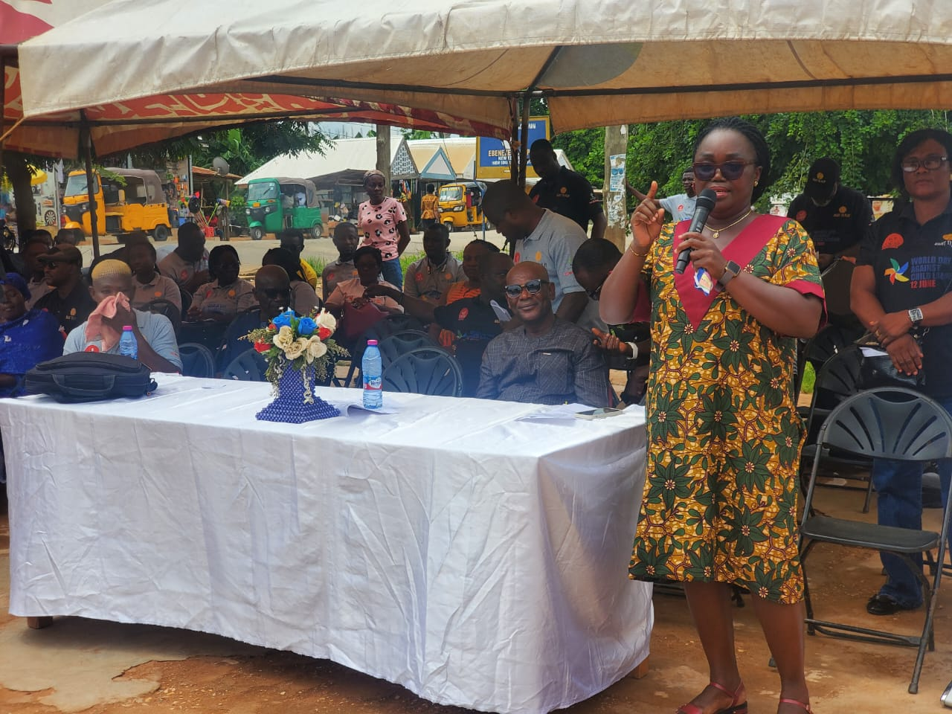
The District Chief Executive for Adansi South District

Hon. Oheneba Kobina Andoh — District Chief Executive, Adansi South
Hon. Andoh spoke on the statutory duty of district assemblies to protect children — a duty, he said, that goes beyond passing resolutions and requires real enforcement, funding, and coordination. He urged residents to report suspected child labour cases rather than look away.

Nana Akua Dwum II — Queen Mother of New Edubiase
The Queen Mother addressed the crowd with what many described as the emotional high point of the speeches. She acknowledged candidly that cultural practice and economic hardship have normalised child labour in some communities, and called on fellow traditional leaders to use their moral authority to shift that norm from within.
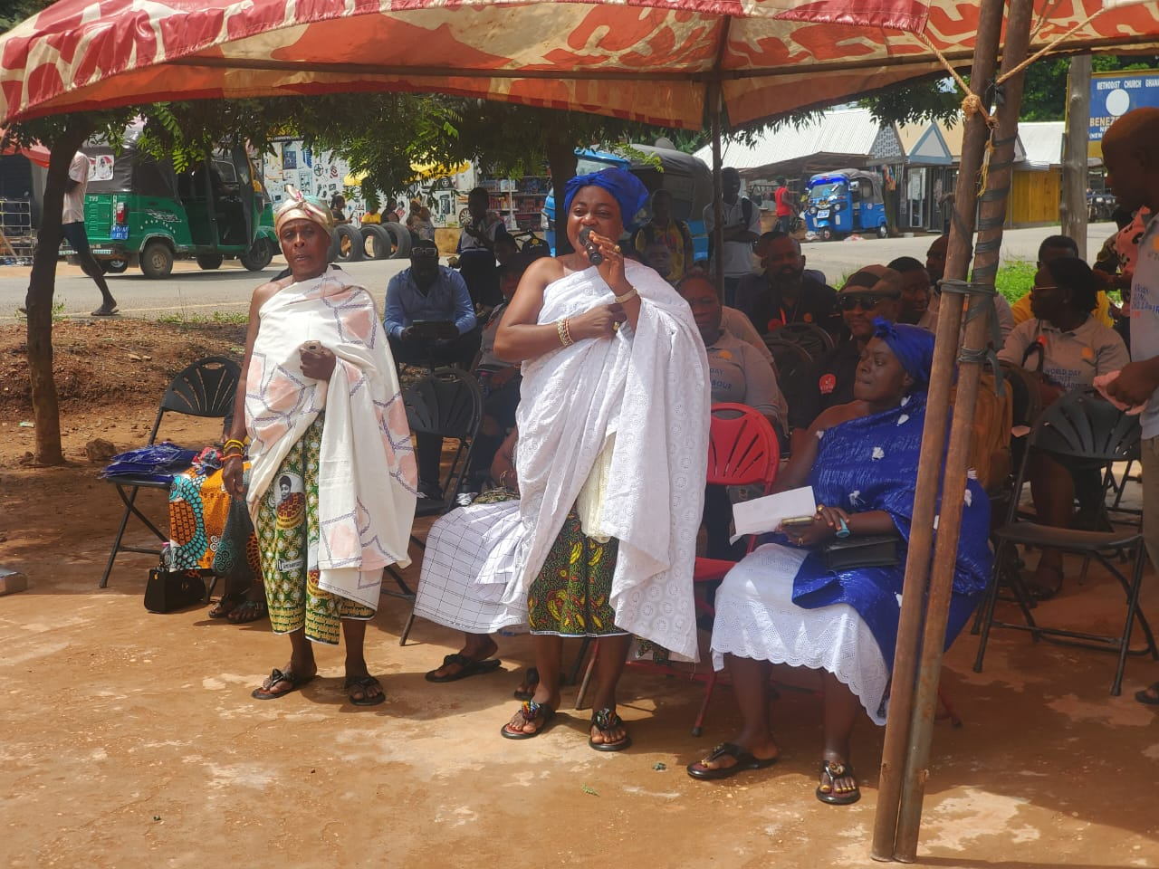
The Queen Mother of New Edubiase addressing participants

Mr. Ebenezer Kofi Asare — Ghana Education Service Director, Adansi South
Mr. Asare laid out the classroom-level cost of child labour: exhausted, absent, or withdrawn pupils falling irreversibly behind. He framed education as the most reliable long-term defence against child labour, and pointed to school feeding and capitation grants as tools that ease the economic pressure on families.
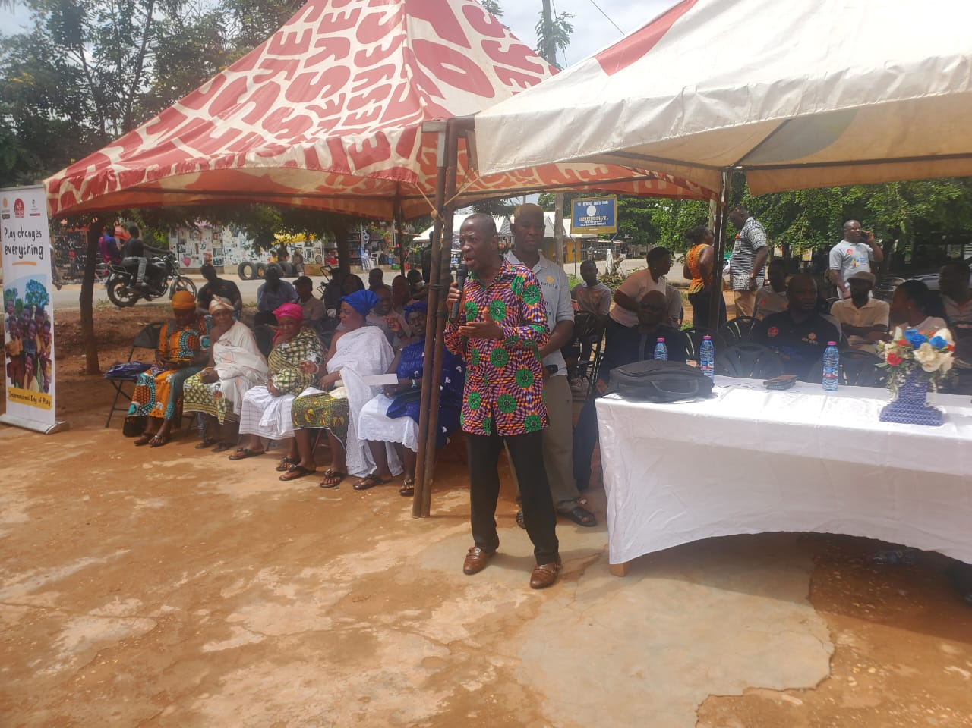
The District Education Director addressing participants

Madam Rahajatu Buwah — Nyonkopa Cocoa
Madam Buwah spoke candidly about the cocoa industry's historical association with child labour and detailed the company's efforts to move past it — community monitoring systems, livelihood support for farming households, and sustained backing for Right to Play's programming in cocoa communities.

The Children Took the Stage Too
Perhaps the most striking part of the day belonged to the pupils themselves. Drama troupes, poets, and cultural dance groups from across the three districts performed original pieces confronting child labour head-on — staging the stark contrast between a child pulled out of school for farm work and one supported to stay in the classroom, and reciting poetry in English and local languages appealing directly to parents and elders.
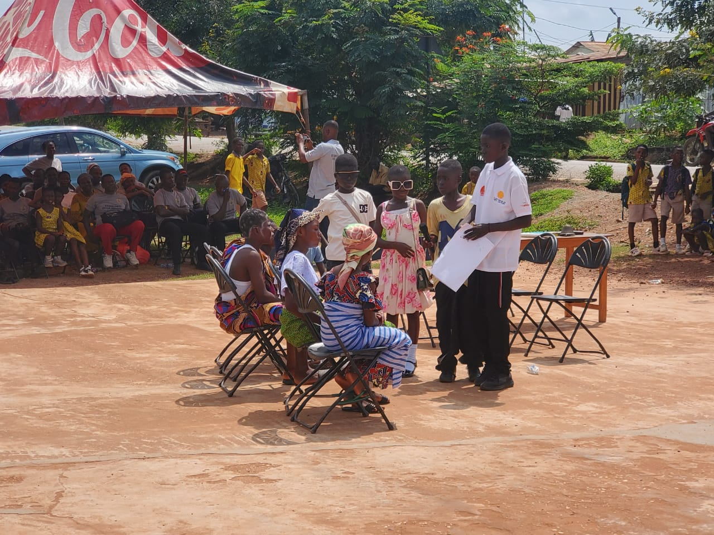
A drama performance by school children on the effects of child labour
Attendees, particularly parents and traditional leaders, singled out these performances as the highlight of the event — a reminder that children are not just the subject of child-protection policy, but active voices in the conversation when given the platform to speak.

What Happens Next
Organisers were candid that a single annual event, however energising, isn't enough on its own. The report emerging from the day lays out a clear set of next steps: formalise the inter-district collaboration through a joint action plan, resource Community Child Protection Committees so they can actually respond to cases rather than just document them, bring traditional authorities formally into district child-protection structures, and keep pushing the cocoa sector to expand livelihood support alongside supply-chain monitoring.
For the three districts, the joint hosting arrangement itself has become part of the message — proof that a problem too big for any one community to solve alone can still be tackled through shared resolve, shared resources, and a shared refusal to look away.
Compiled from the official event report by the Adansi Asokwa District Assembly, Department of Social Welfare & Community Development, June 2026.

